TASK 03
1. Create a comparison table listing the main differences between DDR3, DDR4, and DDR5 RAM, including speed, voltage, and typical use cases.
FEATURE | DDR3 | DDR4 | DDR5
Data transfer speed | 800–2133 MT/s | 1600–3200 MT/s | 4800–8800+ MT/s
Operating voltage | 1.5 V | 1.2 v | 1.1 v
capacity per  module | 1–8 GB | 4–32 GB | 8–64 GB or more
Power efficiency | Lowest of the three | Better than DDR3 | Best nominal operating voltage

2.Open your laptop or desktop (with power disconnected), locate the RAM slots, and take a clear photo of the installed RAM module. Reinstall the RAM module and verify that your system boots up successfully.<br><br><em><strong>Hint:</strong> Refer to your device manual or a trusted YouTube guide if unsure about RAM removal and installation steps.</em>.

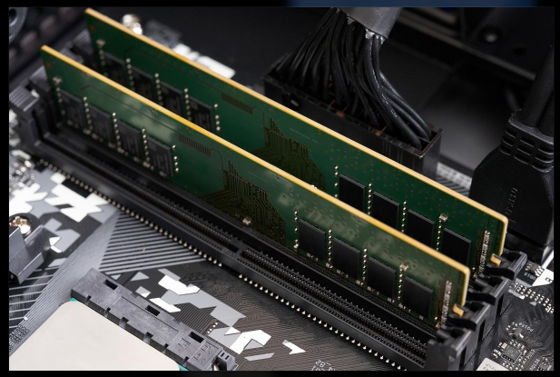
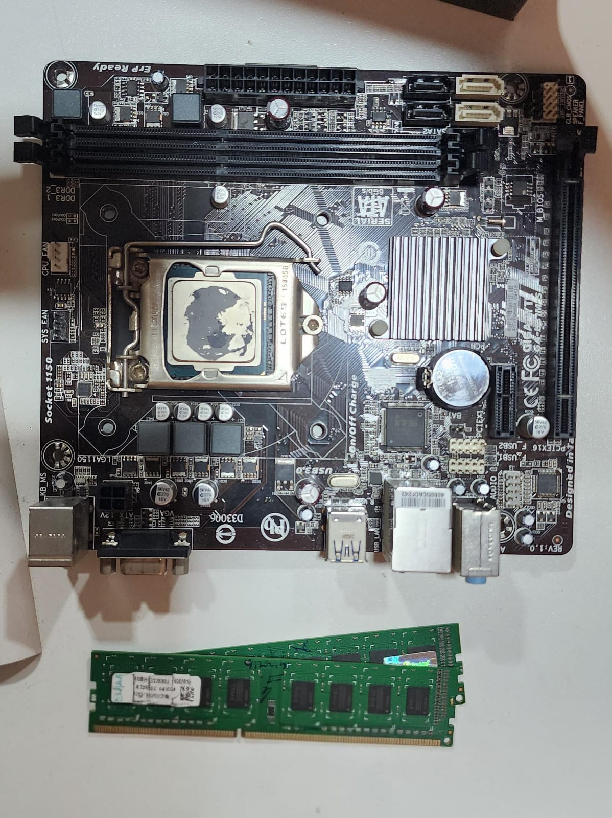
3. List three key differences between HDD, SSD, and NVMe storage types, and for each, name one app or use case (from apps you use daily) that would benefit most from that storage type.
Feature HDD (Hard Disk Drive) SSD (Solid-State Drive) NVMe

1. Speed Slow Faster than HDD Very fast
2. Technology Uses spinning magnetic Uses flash memory with Uses flash memory
disks no moving parts and the PCIe interface
for high-speed data
transfer
3.Cost and Usually cheaper and Costs more per GB Often costs more than
capacity large storage capacity than HDD HDD; price varies
compared with SSDs.
Daily app Storing photos, videos Opening apps like Google Playing graphics-
or use case and documents Chrome and MicrosoftWord heavy games or
loading large video-
editing projects.
4. Remove the storage drive (HDD or SSD) from your system, take a photo of the connector type (SATA, M.2, or NVMe), and reinstall the drive. Confirm that your device recognizes the storage after reassembly.<br><br><em><strong>Constraint:</strong> Only perform this task if you have access to a device you are allowed to open. If not, find and share a YouTube video link showing the process for your laptop/PC model.</em>.
